Review: April 30th 2023:

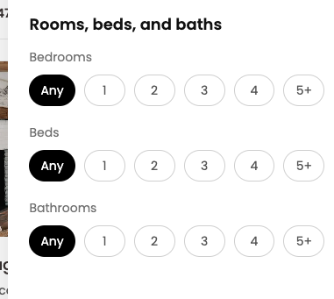

1. Make this selectable and when I hover or click, should be blue

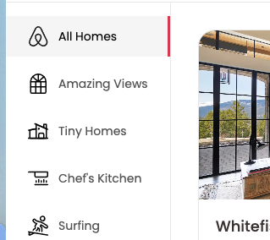

1. Make the sidebar animation smooth. Add some ease in transition

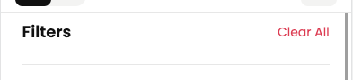

1. Add some extra margin for Filters row in mobile view



1. Add a tooltip when hover over these icons for user to know what that option is about. Also highlight the icon when the user hovers over it.

Review: May 1st 2023:



1. Add some extra margin for Filters row in mobile view